ASSOCIATION OF THE FRIENDS OF INDIA, BASEL
VEREINIGUNG DER FREUNDE INDIENS, BASEL
Postfach 2201, 4001 Basel January 2014
Dear Friends,
We hope that you had a good start into the New Year and wish all our Members a pleasant continuation. we are looking forward to meet many of you at one of our events throughout the year.
As first event we thought of having a cosy and warm get-together with a
FONDUE ON THE RHINE
Saturday, 08. February 2014, 19.15 – 22.45 h. Meeting at 19.00 h (!) latest at Schifflände
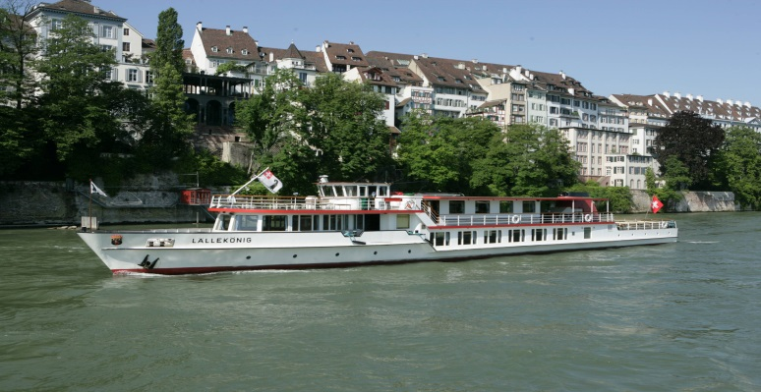
The ship may be the “Lällekönig” as pictured above, or the larger “Christoph Merian”. The Fondue à discretion will be accompanied by music. To be on the safe side we have provisionally made a reservation for 10 persons (one table) for our Association. Since we have to give the definitive number of participants latest three days before the cruise we have to receive registrations latest by Tuesday, 4th February, and cancellations of previous registrations by Wednesday, 5th February. No shows will be charged.
The costs will be CHF 48.- per person for members and 58.- for non-members. They include boarding ticket,^hors-d’oeuvre and fondue without drinks and desert. Should anybody not like cheese fondue, exceptionally a cold hors-d’oevre plate ( non.veg) can be ordered in advance.
The vouchers for boarding and meal have to be obtained on boarding and drinks paid at the end of the dinner. Please register by filling in the form below and sending it to our PO Box address or by sending a mail to contact@afib.ch , giving your name, address and phone number and stating the number of participants. Deadline: 4. February 2014 (received).
Please be at the Schifflände in time (before 19.00 h) in order to have a comfortable boarding.
We are looking forward to seeing you on board at our almost traditional typical Swiss evening.
Your EC
Advance notice: We shall be having our Annual General Body Meeting (AGBM) on Saturday, 05. April 2014. You will be receiving an invitation with the agenda at least 4 weeks before the AGBM.
According to our Constitution, all suggestions for Constitutional Amendments should be announced in the invitation. Any suggestions made at the AGBM itself can only be carried as Resolutions. Therefore, should you have a proposal in mind, which we should vote on at the AGBM, please submit this to us in writing to our PO Box or by e-mail to contact@afib.ch not later than 28. February 2014

Forthcoming event; On Sunday, 16th March we are planning to celebrate HOLI at the
Hirzbrunnen Hall in Basel for members and their friends Please mark the date.

Registration for “Fondue Rundfahrt” (To be sent back to our PO Box by 04. Febr. 2013/ received!)
Name, First name: .............................................................................. Tel..............................................
Address: ...................................................................................
No. of Members with .., ..... without Fondue…..... Non-members with........ without Fondue…..
!! Registration is binding if not cancelled before 06. 02. 2014, by e-mail to contact@afib.ch or phone 078 872 2770 which means that the full costs will have to be charged to participants not turning up unexcused!!

